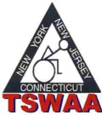

TRI-STATE WHEELCHAIR & AMBULATORY ATHLETICS WOULD LIKE TO WELCOME CAITLIN GOERLICH, JOHN GUIMARAES AND BILL WILKIE TO THE BOARD OF DIRECTORS.

THE BOARD WOULD ALSO LIKE TO THANK CARLOS QUILES, MARGARET REDDEN AND JAMES TANTSITS FOR THEIR CONTRIBUTIONS TO THE ORGANIZATION WHILE SERVING AS MEMBERS-AT-LARGE. THANK YOU!!

